Computer Language Coding Concepts

Related Items & Related Lists Collections in a Diagram
The concept of related items & related lists collections was already covered in the article Related Items & Related Lists Collections. The current article only covers its expression in a diagram.

A related item and related list’s system interface gets an extra member ID In Parent:

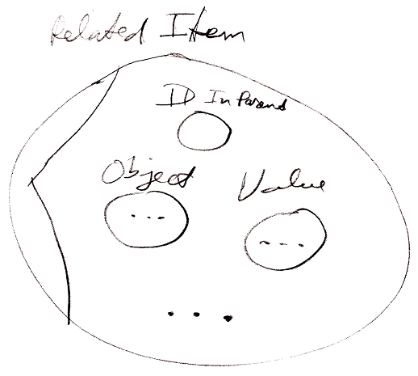

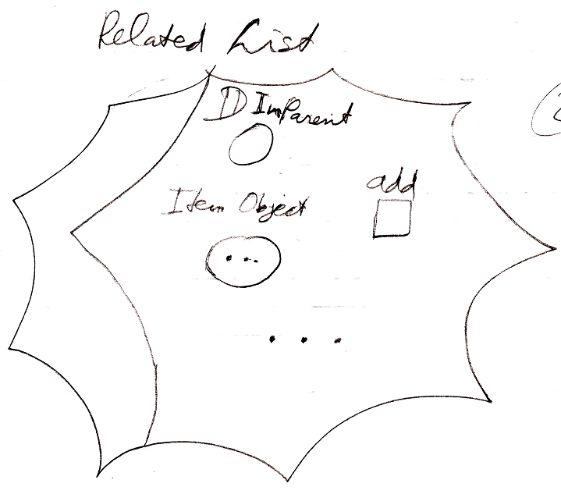

The related items and related lists collections are added to the system interface of the object itself:

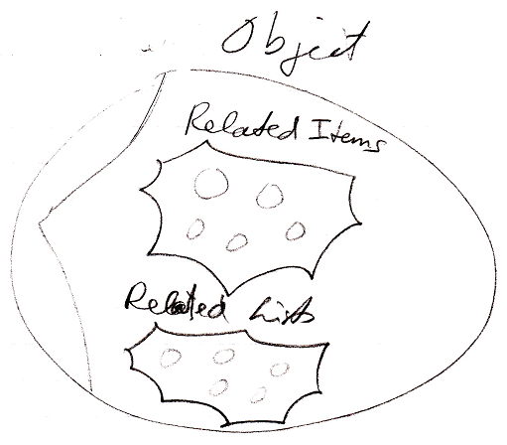

But an object itself is never shown in the diagram. You are always seeing related items or related list items, never the objects themselves. It is not clear yet whether to display the collections as part of the storage variable, that stores the object:

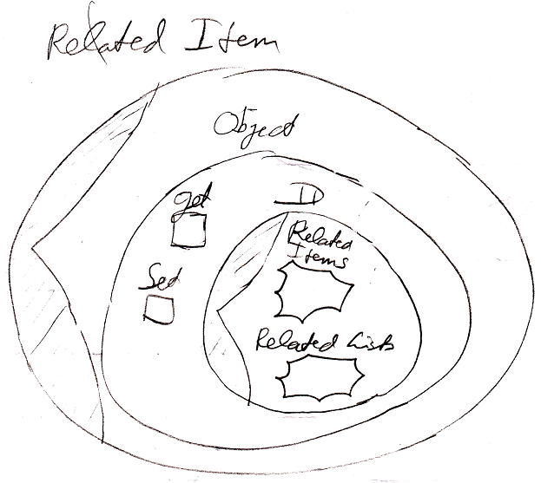

which is closest to how it physically works, or to just dump the two collections inside the system interface of a related item or related list item:

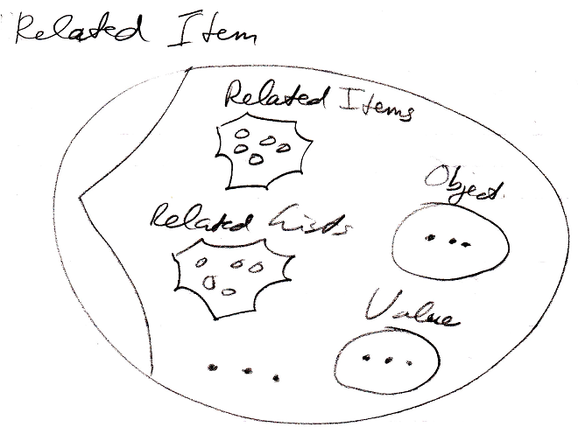

See also: System Objects, Related Items & Related Lists Collections

Author & Copyright: Jan-Joost van Zon Date: July 24, 2008 – July 24, 2008 Location: Oosterhout, The Netherlands Status: Finished

